**FleX PolyPerty**

To develop the property business, Sir Felix asked Mr. Budi to make an application system to handle his property business. Unfortunately, Mr. Budi is on vacation overseas. You, as a well-trained programmer, are asked to make the application prototype using C program language and implement AVL Tree’s data structure.

The Property are ​​regular polygonal shape with 4 to 10 sides. The property has different prices according to the location type. The price is calculated with the following formulas.

|  |  |
| --- | --- |
| Type | Price / Area |
| rural | 2000 |
| metro | 5500 |
| capital | 10000 |

|  |  |
| --- | --- |
| Area for 4 sides Polygon | Area for 5 to 10 sides Polygon. |
| Area = $s^{2}$ | Area = (n x $s^{2}$) / (4 x tan( $π$/ n)) |

s = length of a side.

n = number of sides.

$$π=3.14$$

|  |
| --- |
| Price = Area x Price / Area |

**Figure 1. Flex PolyPerty Menus**

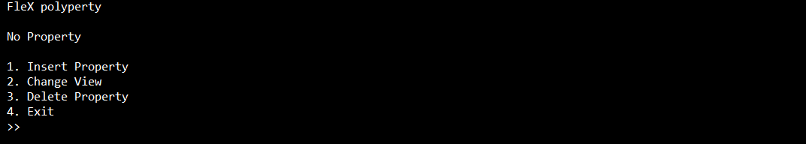

**Figure 2. No Property Menu**

Make 4 Menus:

1. Insert Property

* Ask the user to input the property location type. Validate the input must be between capital, metro, and rural (case sensitive).
* Ask the user to input the number of sides. Validate the input must be between 4 and 10 (inclusive).
* Ask the user to input the side’s length. Validate the input must be between 1 and 1000 (inclusive).
* Insert the property data to the AVL tree.

**Figure 3. Insert Menu**

**Figure 4. After Insert Property**

1. Change View

* Ask the user to input view option. Validate the input must be between pre and in (case sensitive).
* Change the main menu’s view according to the choices.

**Figure 5. Change View Menu**

**Figure 6. View In Order**

**Figure 7. View Pre Order**

1. Delete Property

* Validate if there is no property. If no menu, redirect user to Main Menu.

**Figure 8. No Menu**

* Ask the user to input property id. Validate the id must exist (Case Sensitive).
* Delete property data from AVL Tree.

**Figure 9. Delete Menu**

**Figure 10. After Delete Property**

1. Exit

* The application will be terminated.